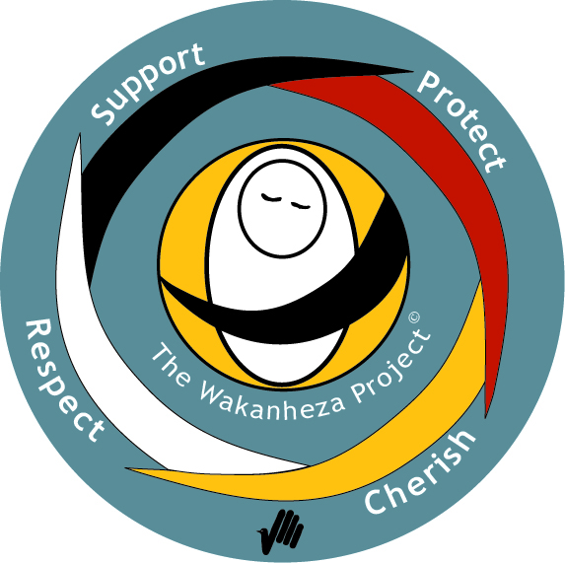 The Wakanheza Project™ - Creating Welcoming Environments

By Marcia Sarnowski

Representatives from many Wisconsin public library systems gathered on May 4 at the Sun Prairie Public Library to learn about the The Wakanheza Project™, a prevention approach to addressing family violence that was developed in 2002 by the Saint Paul – Ramsey County Public Health and The Initiative for Peaceful Families and Communities in Ramsey County.

“Wakanheza” means “sacred being” and is the Dakota word for child. The The Wakanheza Project logo features the words “support, protect, cherish, respect”, all elements in the recognition of children as sacred beings. The principles and purpose of The Wakanheza Project embrace the creation of welcoming and respectful environments and the prevention of harsh treatment of children, but they also apply to young people, adults, and families in public places. As such, they can be very appropriately implemented in library spaces.

Trainers Darleen Simmons and Ginny Brodeen introduced the group to the six principles of The Wakanheza Project (condensed here from the training materials):

**Judgment:**  Recognize, and then suspend our judgments of others.

**Culture:** Open ourselves to all cultures and the opportunity to see beyond differences so that we may all share kindness with all people.

**Powerlessness:** Understand that many/most acts of violence arise from a sense of powerlessness.

**Empathy and respect:** Embrace our ability to show understanding and genuinely offer to help.

**Environment:**  Recognize that environments have significant impacts on behaviors.

**The Moment:** Freeing ourselves to suspend judgment, understand the impacts of powerlessness and environment, appreciate culture, and practice empathy and respect in the present moment.

The Wakanheza Project has been introduced in over 100 organizations in Minnesota and throughout the nation, including museums, faith communities, schools, family service agencies, and libraries: the Saint Paul Public Library incorporates The Wakanheza Project as a core element of their employee training and performance appraisals.

Ginny Brodeen is a librarian and has worked for the Saint Paul Public Library. She commented, “The Wakanheza Project changes how we are seen – by ourselves and others, how our places feel, and how we view our work.”

Each of the library systems which sent participants to the training session will be sharing information about The Wakanheza Project in their own regions. The Winding Rivers Library System training will take place at our continuing education workshop on Thursday, September 8 at the La Crosse Public Library. More details will become available as the day’s activities are developed. Watch this space!

For more information about The Wakanheza Project, visit the website of Saint Paul Ramsey County Public Health: [**http://www.co.ramsey.mn.us/ph/cp/wakanheza.htm**](http://www.co.ramsey.mn.us/ph/cp/wakanheza.htm).

*The Wakanheza Project™ concept and logo were developed, copyrighted, and trademarked by*

*Saint Paul - Ramsey County Public Health.*