### 

### MANITOWOC PUBLIC LIBRARY

707 Quay Street

Manitowoc, WI

(920)686-3000 www.manitowoclibrary.org

MON-THU 9:00-8:00 PM  
FRI 9:00-6:00 PM  
SAT 9:00-3:00 PM  
SUN 12:00-4:00 PM

### TWO RIVERS LESTER PUBLIC LIBRARY

1001 Adams Street

Two Rivers, WI

(920)793-8888 www.lesterlibrary.org

MON-THU 10:00-8:00 PM  
FRI 10:00-5:30 PM  
SAT 10:00-2:00 PM  
SUN Closed

# Manitowoc Calumet Library System

# Member Library Information

## HOURS & CONTACT INFORMATION

*Check for holiday and summer hours*

### BRILLION PUBLIC LIBRARY

326 N. Main Street

Brillion, WI

(920)756-3215 www.brillionwi.gov/library

MON-THU 10:00-7:00 PM

FRI 10:00-6:00 PM

SAT 9:00 AM-12:00 PM

SUN Closed

### CHILTON PUBLIC LIBRARY

221 Park Street

Chilton, WI

(920)849-4414 www.chiltonlibrary.org

MON-THU 10:00-8:00 PM

FRI 10:00-6:00 PM

SAT 10:00-1:00

SUN Closed

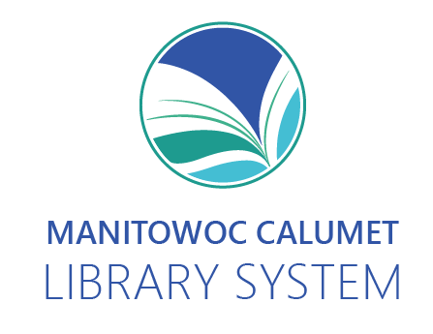

### 

### KIEL PUBLIC LIBRARY

511 3rd Street

Kiel, WI

(920)894-7122

www.kiellibrary.org

MON-THU 9:00-8:00 PM  
FRI 9:00-6:00 PM

SAT 9:00-1:00 PM

SUN Closed

### NEW HOLSTEIN PUBLIC LIBRARY

2115 Washington Street

New Holstein, WI

(920)898-5165 www.newholsteinlibrary.org

MON- FRI 9:00-6:00 PM

SAT 9:00-1:00 PM

SUN Closed