**6.**

**5.**

**4.**

**3.**

**2.**

**1.**

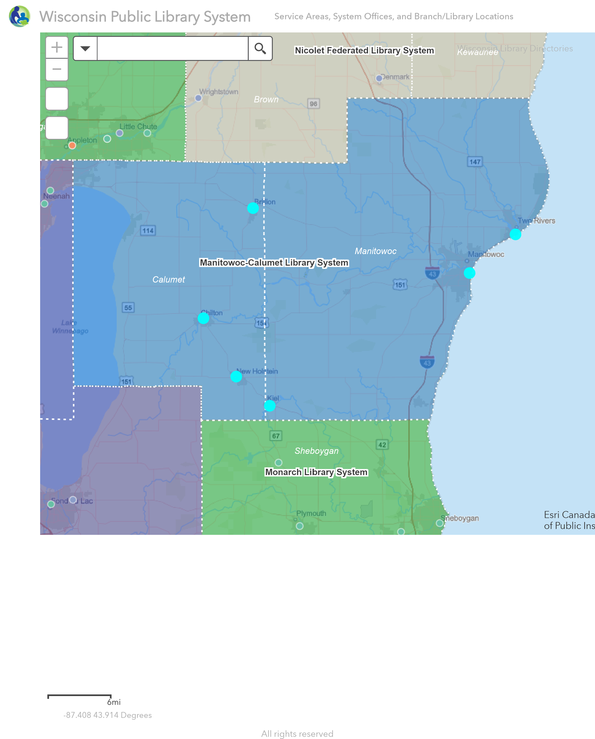

**Manitowoc-Calumet Library System Member Libraries**

**1. Brillion Public Library 2. Chilton Public Library 3. Kiel Public Library**

326 N Main St Brillion, WI 54110-1146 221 Park St Chilton, WI 53014-1433 511 3rd St Kiel, WI 53042-1408

(920) 756-3215 (920) 849-4414 (920) 894-7122

Director: Lydia Blatz Director: Glenny Whitcomb Director: Julia Davis

[www.ci.brillion.wi.us/departments/library](http://www.ci.brillion.wi.us/departments/library) [www.chiltonlibrary.org](http://www.chiltonlibrary.org) [www.kiellibrary.org](http://www.kiellibrary.org)

**4. Lester Public Library 5. Manitowoc Public Library**

1001 Adams St Two Rivers, WI 54241-3544 707 Quay St Manitowoc, WI 54220-4539

(920) 793-8888 (920) 686-3000

Director: Jeffrey Dawson Director: Karin Adams

<https://www.lesterlibrary.org> [www.manitowoclibrary.org](http://www.manitowoclibrary.org)

**6. New Holstein Public Library**

2115 Washington St New Holstein, WI 53061-1044

(920)898-5165

Director: D Hankins

[www.newholsteinlibrary.org](http://www.newholsteinlibrary.org)